COURT OF THE LOK PAL (OMBUDSMAN),
ELECTRICITY, PUNJAB,
PLOT NO. A-2, INDUSTRIAL AREA, PHASE-1,
S.A.S. NAGAR (MOHALI).

APPEAL NO. 27/2020

Date of Registration : 29.06.2020
Date of Hearing : 13.08.2020
Date of Order : 13.08.2020
Before:
Er. Gurinder Jit Singh,
Lokpal (Ombudsman), Electricity, Punjab.

In the Matter of:
Nitin Kumar,
H.No. E-164, B.R.S. Nagar,
Ludhiana.
Contract Account Number: U14MS140018K

...Appellant
Versus
Addl. Superintending Engineer,
DS Division, PSPCL,
Ludhiana -Moga Road,
Adda Dakha, Distt. Ludhiana. ...Respondent

Present For:
Appellant : Sh. Nitin Kumar,
Appellant.

Respondent : Er. Dharam Pal
Addl. Superintending Engineer,
DS Division, PSPCL,
Adda Dakha, Distt. Ludhiana.
Before me for consideration is an Appeal preferred by the Appellant against the order dated 29.05.2020 of the Consumer Grievances Redressal Forum (Forum), Ludhiana in Case No. CGL-034 of 2020, deciding that:
“The amount of Rs. 76,948/- charged as difference of tariff from 01.01.2018 to 30.07.2019 vide notice no. 2402 dated 18.11.2019 is correct and recoverable.
Further as per the request of the Petitioner, the amount is allowed to be deposited in six instalments without interest.”
2. Registration of the Appeal
A scrutiny of the Appeal and related documents revealed that the Appeal was received in this Court on 29.06.2020 i.e. within one month of receipt of order dated 29.05.2020 of the CGRF, Ludhiana in Case No. CGL-034/2020. Besides, the Appellant had deposited ₹ 15,390/- on 14.01.2020 on account of 20% of disputed amount of ₹ 76,948/-. However, the Appellant was asked to deposit balance 20% of the disputed amount with the PSPCL. Accordingly, the Appellant deposited the ₹ 15,390/- on 22.07.2020 with PSPCL. However, the Appeal was registered and copy of the same was sent to the Addl. Superintending Engineer/ DS Division, PSPCL, Adda Dakha, Distt. Ludhiana for sending written reply/parawise comments with a copy to the office of the CGRF, Ludhiana under intimation to the Appellant vide this office letter no. 519-21/OEP/A-27/2020 dated 30.06.2020.
3. Proceedings
With a view to adjudicate the present dispute, a hearing was fixed for 27.07.2020 and intimation to this effect was sent to both the sides vide letter No. 608-09/OEP/A-27/2020 dated 22.07.2020. But on the request of the Appellant vide e-mail dated 22.07.2020, the hearing was adjourned to 13.08.2020 and both the Appellant and the Respondent were informed accordingly vide letter No. 632-33/OEP/A-27/2020 dated 24.07.2020. The hearing held on 13.08.2020 was attended by the the Appellant and the Respondent.
4. Submissions made by the Appellant and the Respondent:
With a view to adjudicate the dispute, it is necessary to go through written submissions made in the Appeal by the

Appellant and reply of the Respondent as well as oral submissions made by them along with material brought on record by both the sides.
- Submissions of the Appellant
- Submissions made in the Appeal
The Appellant made the following submissions in the Appeal, received on 29.06.2020, for consideration of this Court:
- The Appellant was having MS category connection with sanctioned load of 39.95 kW and CD as 44.40 kVA.
- The account of the Appellant was checked by Revenue Audit Party which issued Half Margin No. SP 04 dated 25.09.2019 stating that the billing of the Appellant’s Dairy Farming connection was being done under AP metered category tariff whereas as per CC No. 25/2019 dated 31.05.2019, the billing should have been done under normal Industrial Tariff. So, the amount of ₹ 76,948/- was charged on account of difference of Tariff from 01.01.2018 to 30.07.2019. As a result, notice bearing No. 2402 dated 18.11.2019 was issued to deposit this amount.
- The Appellant filed a case in office of the CGRF, Ludhiana which decided that amount charged to the Appellant was recoverable.
- The Appellant did not agree with the decision of the Forum.
- The Appellant’s connection was still running under Dairy Farming and the work was also the same. Billing was being done on AP Metered Tariff by the PSPCL which had never issued any notice regarding MS Tariff. If the Notice had been issued earlier, then, the Appellant would have either raised its objection or reduced its load but no Notice was issued regarding charging of industrial tariff. Its connected load was very less.
- The Forum, instead of seeking the clarification itself from C.E./Commercial, PSPCL, asked the Respondent (ASE/DS Adda Dakha Division,) to get the clarification from CE/Commercial, PSPCL, Patiala.
- Necessary clarification may please be obtained from PSERC, Chandigarh (Competent Authority) as to whether the amount charged by Audit Party was correct or not. Since it was nowhere written in the said circular that the amount be charged for the previous period.
- If the submissions made above are not agreeable/justifiable, then, the account may please be overhauled for six months only as per instruction/regulations of PSPCL and not for the period from 01/2018 to 30.07.2019 (as pointed out by Audit Party) so that the consumer was not overburdened with this amount which was illegal and non chargeable. The case may please be considered sympathetically and the Appellant be allowed to pay the amount at least in 15 installments because in Dairy Farming, everyone was in hand to mouth situation. In this COVID-19 pandemic situation, the Appellant had been suffering huge loss.
- Submissions of the Appellant in Rejoinder
Before the start of hearing on 13.08.2020, the Appellant submitted its rejoinder to written reply of the Respondent. The same was taken on record and a copy of the same was given to the Respondent.
- Submissions of the Respondent
The Respondent, in its defence, made the following submissions for consideration of the Court:
- The Appellant was having a Medium Supply category connection bearing account No. MS-14/0018-K, in his name with sanctioned load (SL) of 39.75 kW and contract demand as 20 kVA. The account of the Appellant was checked by Revenue Audit Party and it was found that the Appellant was being billed under AP category but as per CC Nos. 24/2018 and 25/2019, the Appellant was required to be billed under MS category.
- Accordingly, the Revenue Audit Party charged the Appellant vide Half Margin No. SP-04 dated 25.09.2019, on account of difference of tariff, amounting to ₹ 76,948/- for the period from 01.01.2018 to 30.07.2019.
- The Appellant did not deposit this amount and filed a case for consideration before CGRF, Ludhiana in January, 2020.
- A clarification was sought vide letter No. 1004 dated 26.02.2020, from Chief Engineer/Commercial, PSPCL, Patiala regarding change of tariff for already running dairy farm connections.
- The Addl. SE/ Sales-2, Office of the Chief Engineer/ Commercial, PSPCL, Patiala clarified vide Memo No. 142 dated: 14.05.2020 that the amount charged to the consumer as per observation of Revenue Audit Party was correct.
- Keeping these facts in view the Forum had decided that the amount charged to the consumer was recoverable and this amount be recovered in six installments without interest.
- Aggrieved, the Appellant filed present Appeal and refused to make the payment of the amount, held recoverable by the Forum.
- It was correct that the Appellant was not issued any notice and that he was being billed under AP category. However, as per CC No. 25/2019 and CC No. 24/2018, the consumer was required to be billed under MS category and on the basis of Half Margin No. SP-04 dated 25.09.2019, the Appellant was charged ₹ 76,948/- for the period 01.01.2018 to 30.07.2019.
- The Appellant had got decreased his CD from 44.400 kVA to 20.00 kVA.
- The Appellant had also agreed to the clarification received from office of the Chief Engineer/ Commercial, PSPCL, Patiala and requested in writing to the Forum that he had suffered a lot due to Corona Virus and his financial status was not good. He was unable to deposit this huge amount in one go and requested for seven installments without interest. The Forum after considering the request of the Appellant, allowed the amount to be deposited in six installments without interest.
- The contention of the Appellant was that he was never issued any notice regarding MS tariff was not sustainable/ meaningless in view of the advice already taken regarding the instructions to charge Industrial Tariff to Dairy Farm from the Competent Authority i.e Chief Engineer/ Commercial, PSPCL, Patiala. The Appellant had also agreed to the clarification during proceedings in the Forum.
5. Analysis and Findings
The issue requiring adjudication is the maintainability of the present Appeal challenging the order dated 29.05.2020 of the CGRF, Ludhiana in Case No. CGL-034 of 2020 deciding as under:
“The amount of Rs. 76,948/- charged as difference of tariff from 01.01.2018 to 30.07.2019 vide notice no. 2402 dated 18.11.2019 is correct and recoverable.
Further as per the request of the Petitioner, the amount is allowed to be deposited in six instalments without interest.”
My findings on the points emerged, deliberated and analyzed are as under:-
- The present dispute arose in 9/2019 when the Revenue Audit
Party checked the account of MS Category connection of the Appellant having sanctioned load of 39.95 kW and contract demand as 44.40 kVA. The Audit Party observed that the Appellant, who was sanctioned the electricity connection for Dairy Farming, was being billed under AP Metered Category Tariff instead of under Normal Industrial Category as required. As a result, the Revenue Audit Party issued Half Margin No. SP-04 dated 25.09.2019 and charged a sum of ₹ 76,948/- on account of difference of Tariff for the period 01.01.2018 to 30.07.2019. Based on the audit observation, the Respondent issued a Notice, bearing No. 2402 dated 18.11.2019, asking the Appellant to deposit the said amount. The Appellant did not deposit the charged amount and approached the Forum in 01/2020 for relief.
- With a view to establish about the maintainability of the present Appeal, it is worthwhile to peruse the observations of the Forum in the Case No. CGL-034/2020 (under challenge) at page 8-9 which are reproduced below:
“Forum observed that the matter regarding applicability of tariff needs to be got clarified from the o/o Chief Engineer/Commercial, PSPCL Patiala, therefore Respondent was directed to get the clarification in this regard. Respondent submitted the copy of clarification given by o/o Chief Engineer/Commercial, PSPCL Patiala, vide his Memo no. 142 dated 14.05.2020. As per this letter, it was clarified that as per CC No. 04/2015, 24/2018 and 25/2019, the connection of Dairy Farming comes under Industrial tariff and the instructions are also applicable on Dairy Consumers of MS and LS category. Petitioner agreed to this clarification however, he requested in writing that he suffered a lot due to Coronavirus and his Financial status is not good. He could not deposit this huge amount in one go and requested for fifteen installments without interest.
From the above, Forum is of the opinion that as per the clarification received from the o/o Chief Engineer/Commercial, PSPCL Patiala, the amount charged by the Audit Party is recoverable. The Petitioner has also agreed to deposit the amount.
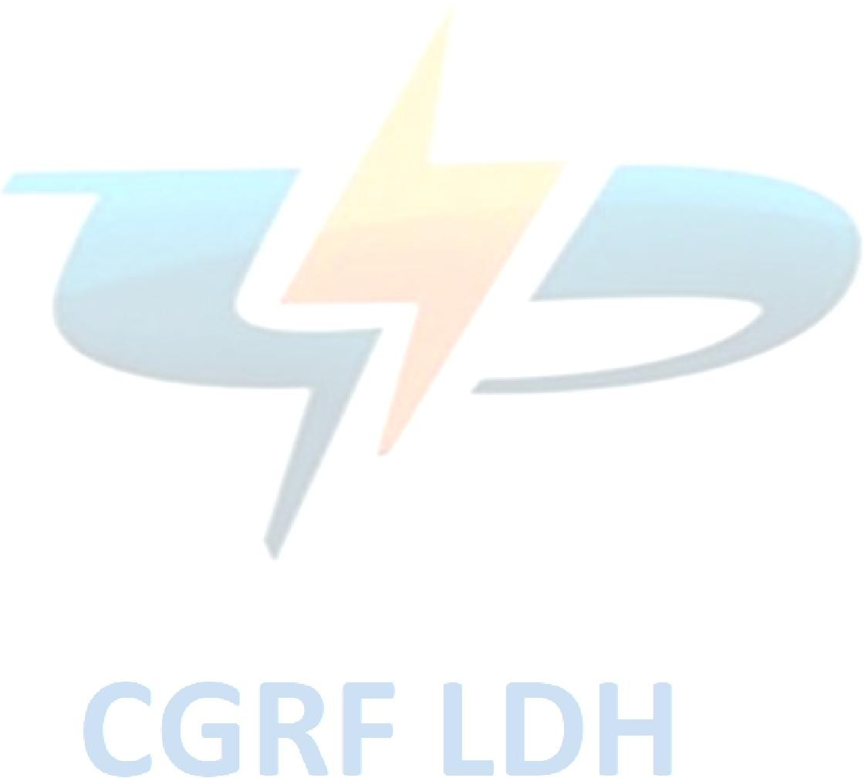
Keeping in view the above, Forum came to the unanimous conclusion that the amount of Rs. 76948/- charged as difference of tariff from 01.01.2018 to 30.07.2019 vide notice no. 2402 dated 18.11.2019 is recoverable. However as per the request of the Petitioner, the amount can be allowed to be deposited in six installments without interest.”
- During hearing in this Court on 13.08.2020, the Appellant was apprised that he had agreed to the decision of the Forum by giving request letter in the office of the Secretary, CGRF, Ludhiana (referred to in proceeding dated 27.05.2020 in Forum case file) stating that:
“As per the clarification the amount charged is recoverable but due to Coronavirus he has suffered a huge loss and thus requested for 15 no. installments without interest.”
The attention of the Appellant was also invited towards Regulation 2.50 of the PSERC (Forum and Ombudsman)

Regulations’ 2016 which reads as under:
“The Forum may settle any grievance in terms of an agreement reached between the parties at any stage of the proceedings before it and there shall be no right of representation before the Ombudsman against such an order.”
In response, the Appellant informed the Court that he was not aware of the provisions of Regulation 2.50 referred to above. However, the Appellant admitted during hearing on 13.08.2020 that the decision of the Forum was as per agreement with him.
(iv) From the above analysis, it is concluded that the Appellant, by giving his request in writing in the Forum for deposit of recoverable amount in installment without interest lost its right to seek remedy from this Court in terms of provisions contained in Regulation 2.50 of PSERC (Forum and Ombudsman) Regulations-2016. Hence, the present Appeal is not maintainable in this Court.

6. Decision
As a sequel of above discussions, the Appeal is dismissed as the same is not maintainable as per Regulation 2.50 of PSERC (Forum and Ombudsman) Regulations, 2016.
8. The Appeal is disposed of accordingly.
9. In case, the Appellant or the Respondent is not satisfied with the above decision, it is at liberty to seek appropriate remedy against this order from the Appropriate Bodies in accordance with Regulation 3.28 of the Punjab State Electricity Regulatory Commission (Forum and Ombudsman) Regulations-2016.
August 13, 2020 (GURINDER JIT SINGH)
SAS Nagar (Mohali) Lokpal (Ombudsman)
Electricity, Punjab.

